Chief Election Commissioners of India
S No. | Name | Office Tenure
1. | Sukumar Sen | 21 March 1950-19 December 1958
2. | K.V.K. Sundaram | 20 December 1958-30 September 1967
3. | S.P. Sen Verma | 1 October 1967-30 September 1972
4. | Dr Nagendra Singh | 1 October 1972-6 February 1973
5. | T. Swaminathan | 7 February 1973-17 June 1977
6. | S.L. Shakdhar | 18 June 1977-17 June 1982
7. | R.K. Trivedi | 18 June 1982-31 December 1985
8. | R.V.S. Peri Sastri | 1 January 1986-25 November 1990
9. | Smt V.S. Rama Devi | 15 November 1990 to 12 December 1990
10. | T.N. Seshan | 12 December 1990-11 December 1996(on leave vacancy of R.V.S. Peri Sastri)
11. | M.S. Gill | 12 December 1996 - 13 June 2001
12. | J.M. Lyngdoh | 14 June 2001 - 7 February 2004
13. | T.S. Krishna Murthy | 8 February 2004 - 15 May 2005
14. | B.B. Tandon | 16 May 2005 to june 29, 2006

15. N. Gopalaswami 30 June 2006 to April 19, 2009
16. Naveen Chawla April 20, 2009 to till date

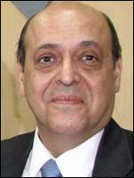

Mr. Navin Chawla

Mr. Navin Chawla (born on 30th July 1945) has been declared as the new Chief Election Commissioner of India by Honbl'e President Smt. Pratibha Devi Singh Patil. Mr. Chawla will hold the charge from April 20, 2009, as Mr. N. Gopalaswami is getting retired on the same date. Mr. Chawla will become the 16th Chief Election Commissioner of India and will hold the office charge till July 29, 2010, as he will turn 65 years of age.

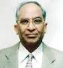

B.B. Tandon | 16 May 2005 to April 19, 2009

Brij Behari Tandon (Retd. IAS) (68 years) is M.A. (Economics) and LLB from the University of Delhi. He has served as Secretary to the Government of India and also as a member of the Securities & Exchange Board of India. He has also been the Chief Election Commissioner of India. Presently, he is also on the board of few renowned Companies such as Adani Power Ltd., Canara Bank, Jaiprakash Power Ventures Ltd, etc. The Company is immensely benefited by his innovative administration and human resource management. He is chairman of the Remuneration Committee of the Company.

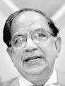

T.S. Krishnamurthy

Sixty-three-year-old T.S. Krishnamurthy, the Chief Election Commissioner of India, wants to remove the impression that the CEC is a "larger-than-life" person, as he explains.

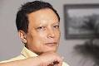

James Michael Lyngdoh

Of Khasi tribal origin, Lyngdoh hails from the northeastern state of Meghalaya. Lyngdoh is the son of a district judge.
He completed his education in Delhi, at St Stephen's College.
In 1997, the president named Lyngdoh one of India’s three election commissioners. By 2001 he was chief election officer.Lyngdoh soon faced crises in two of India’s most troubled states. In Jammu-Kashmir, where India was locked in a potentially explosive standoff with Pakistan and local secessionists, state elections fell due in 2002. Many people doubted that they could be conducted credibly. Lyngdoh thought otherwise. Pushing ahead despite a vicious cross-border assassination campaign .^{[citation needed]}, and a boycott, the Election Commission updated and verified the election rolls, introduced voter identity cards, and added a thousand new voting sites. The Commission recruited nonpartisan poll officers for every polling station.

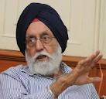

Name | Dr. M.S. Gill
Father's Name | Col. Pratap Singh Gill
Date of Birth | 14/06/1936
Birth Place | Punjab
State Name | Punjab
Educational Qualifications | Senior Cambridge, B.A. (Honours), M.A., Ph.D., Diploma in Development Studies, University of Cambridge Doctor of Science (Honoris Causa) : Punjab Agriculture University, Panjab University, Haryana Agriculture University, Madras University, Gauhati University and Guru Nanak Dev University, Amritsar
Positions Held | 1961-62 Deputy Commissioner and Collector, Lahaul and Spiti (now in Himachal Pradesh) 1965-67 Collector and Deputy Commissioner of Districts Ambala (now in Haryana) and Jalandhar (Punjab) 1977-81 Principal Secretary to the Chief Minister of Punjab 1985-88 Development Commissioner, Punjab 1988-92 Secretary, Department of Chemicals, Petro-Chemicals and Pharmaceuticals, Government of India 1992-93 Secretary, Ministry of Agriculture and Cooperatives, Government of India 1993-96 Election Commissioner of India 1996-2001 Chief Election Commissioner of India

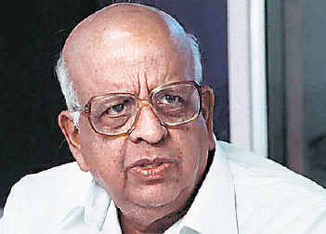

Tirunellai Narayana Iyer Seshan

Tirunellai Narayana Iyer Seshan ( Malayalam: ടി .എന്‍ . ശേഷന്‍ Tamil: or T. N. Seshan was born in a Tamil speaking Kerala Iyer family in Thirunellai, Palakkad district, Kerala. He was the 10th Chief Election Commissioner of India from December 12, 1990 to December 11, 1996.^{[1]}
As the Chief Election Commissioner of India he made history by introducing innovative electoral reforms and making the Election Commission a powerful body. He may be rightfully termed as the most visible public figure who redefined the status and visibility of a C.E.C in India. His name became synonymous with transparency, efficiency and forward vision during his tenure as the C.E.C. He used this to hone his political ambitions by contesting for the post of President of India in 1997 (though he lost to K.R. Narayanan). He came up with the vision of an election-card for every rightful voter in India, something that is regarded as the Indian equivalent of the U.S Social Security card.

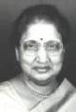

Ms V.S. Rama Devi
Ms Rama Devi was elected as chief Election Commissioner on 15 Nov 1990.
The first woman Governor of Karnataka, V.S. Rama Devi, demitted office this evening, convinced that the Constitution did not envisage governors to be anything more than figureheads.
Ms. Rama Devi became Governor of Karnataka on December 2, 1999. Earlier, she was Governor of Himachal Pradesh from July 26, 1997.

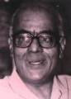

R.V.S. Peri Sastri | 1 January 1986-25 November 1990

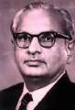

R.K. Trivedi | 18 June 1982-31 December 1985

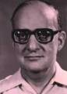

S.L. Shakdhar | 18 June 1977-17 June 1982

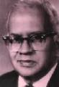

T. Swaminathan | 7 February 1973-17 June 1977

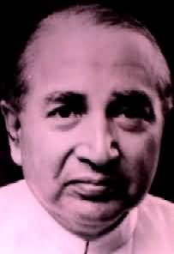

Dr Nagendra Singh | 1 October 1972-6 February 1973

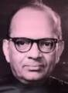

S.P. Sen Verma | 1 October 1967-30 September 1972

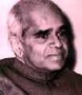

K.V.K. Sundaram | 20 December 1958-30 September 1967

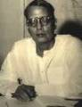

Sukumar Sen | 21 March 1950-19 December 1958

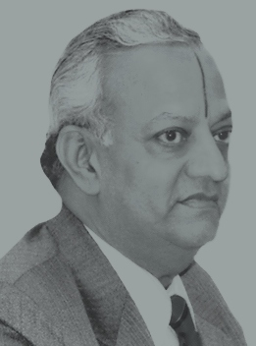

N. Gopalaswami

N. Gopalaswami, is a former Chief Election Commissioner of India. He is a 1966 batch Indian Administrative Services officer belonging to Gujarat cadre.He took over the charge of CEC on June 30, 2006 and has retired in April 2009.

