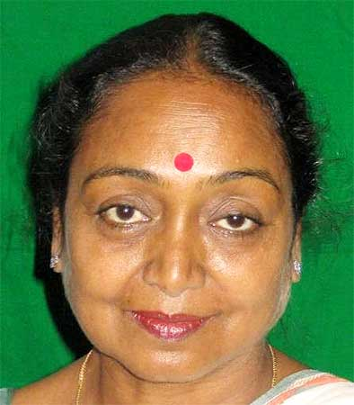

Five-term Lok Sabha Member of Parliament Meira Kumar is set to the first woman Speaker of the Lok Sabha after she emerged as the consensus candidate of the ruling United Progressive Alliance and the Opposition Bharatiya Janata Party.
Kumar, who is the daughter of late Congress stalwart Jagjivan Ram, won from Sasaram in Bihar. She quit the Indian Foreign Service in 1985 to join politics.

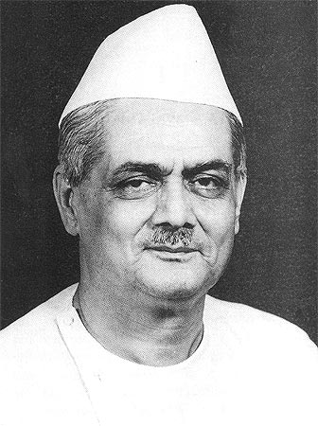
Speaker of Lok Sabha : G. V. Mavalankar
Mavalankar headed the planning of India`s Parliament for a period of over ten years from1946 to1956. As Speaker of the First Lok Sabha of a new born nation, he observed the decorum of the House and also enforced it on others. When Mavalankar presided over the Lok Sabha, the country was to witness his unique qualities as an institution-builder. Because he could link the past precedents with the fresh needs and effect changes while maintaining continuity, his period of Speakership was the most fruitful one for the evolution of parliamentary procedures in India. Not only did he introduce several new rules and procedures, he also modified the existing ones to suit the new conditions.

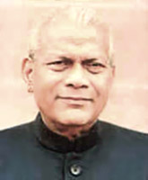

Rabi Ray , Former Speaker of Lok Sabha

Kendrapara constituency in Orissa on the Janata Dal ticket. He was unanimously elected as the Speaker of the Ninth Lok Sabha, on 19 December 1989. Rabi Ray guaranteed members that so long as he was the Speaker he would remain above party politics and would remain fair to all. Rabi Ray`s possession as Speaker endured a short period of fifteen and a half months. In each Session, he faced many challenges, which he tackled with finesse and steadfastness. He initiated certain procedural innovations, as well as gave the decision on some problematic procedural and related issues, which have definitely made the functioning of Parliament far more valuable as an institution mirroring the urges and aspirations of the common people.

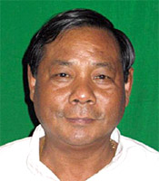

P.A Sangma, Former Speaker of Lok Sabha

P.A.Sangma is a popular figure in the Indian political circuit. He presided over the eleventh Lok Sabha as a speaker and is well known for his jovial, friendly and warm character.
Session for the future set a National Agenda and took stock of the achievements. In the Indian parliamentary history, opening the Special Session, for the first time the Speaker addressed the House and emphasized the need for a second freedom struggle-"freedom from our own internal contradictions, between our prosperity and poverty, between the plenty of our resource endowments and the scarcity of their prudent management, between peace and tolerance and the current conduct sliding towards violence, intolerance and discrimination".

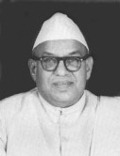

M. Ananthasayanam Ayyangar
M. Ananthasayanam Ayyangar stepped in to as the first Speaker of Lok Sabha to fill the void, which was created soon after the sudden demise of G.V. Mavalankar. M.A Ayyangar proved himself compatible to carry on the incomplete task of solidifying the gains of freedom and of sprouting a healthy parliamentary culture in the new Republic. Ayyangar left an ineffaceable indentation of his personality through a public life straddling over six decades as a lawyer, as a social activist and freedom fighter, as an outstanding parliamentarian and Speaker and as a distinguished scholar, in every area he chose to tread on in life.

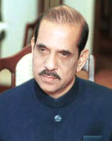

Early Life of Manohar Joshi
This Indian Politician from the Shiv Sena party was born in a Deshstha Brahmin Family on 2nd December 1937. Manohar Joshi was educated in Mumbai. This Bachelor of Law also holds a Master`s degree of Arts and is proficient in Marathi, Hindi, English and Sanskrit.

Political Career of Manohar Joshi
This multifaceted personality on the year 1976 was elected to the Legislative Council from the Shiv Sena and the journey of his political career took its start. After the election he holds the position of the Mayor of Mumbai City during 1976 to 1977. In the year 1990 he was voted to the Legislative Assembly from a Shiv Sena ticket. In the years ahead after he became a member of the State Legislature, his close connection with the Mumbai city and his appreciation of various developmental issues helped him convincingly champion the cause of Mumbai. When the SS-BJP`s coalition beat the Congress in the State Elections, he became the first non-Congress Chief Minister of Maharashtra.

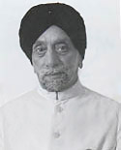

Sardar Hukam Singh, Indian Speaker

The charming personality, Hukam Singh was born on 30 August 1895 at Montgomery, now a part of Pakistan. In 1917, Hukam Singh did his graduation from the Khalsa College, Amritsar, after finishing his matriculation from the Government High School, Montgomery. Thereafter, at the Law College, Lahore he studied Law and started practicing in his hometown Montgomery after passing out in 1921.

Hukam Singh was harked back for the third time to the Lok Sabha, through the General Elections that was held in 1962. This time he contested on a Congress ticket from the Patiala parliamentary constituency. Hukam Singh without dissent was elected as the Speaker of the Third Lok Sabha having been tested and fully confirmed his credentials. It was believed that the office of the Speaker was safe in the hands of Hukum Singh, who ardently endorse the self-esteem of Parliament and the civil rights and constitutional rights of its members.

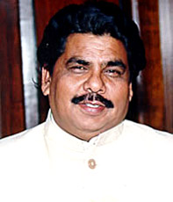

G.M.C. Balyogi , Former Speaker of Lok Sabha

G.M.C. BalyogiAs he was grown up in a small village, Balayogi had to travel to Guttenadeevi village for his primary education. He received his Post Graduate degree in the city Kakinada and a law degree from Andhra University, Visakhapatnam. In the year 1980, Balayogi started his legal career at the Bar in Kakinada under the guidance of Shri Gopalaswamy Shetty. He was chosen as a First Class Magistrate in 1985. To start again his legal practice, he resigned from the Service and returned to the Bar in Kakinada.

On 22 October 1999, Balayogi was unanimously re-elected as the Speaker of the 13th Lok Sabha. A wide variety of socio-political shades, were being displayed by the enclosure of a large number of regional parties, had obviously made it quite an awesome body to preside over. Balayogi as the Speaker had observed his first and foremost duty would be to endorse and preserve the dignity and honor of the House. He gave the assurance to all the sections of the House as the Presiding Officer, he would be guided by the concept of combined wisdom and his actions would be non-partisan. Balayogi left an indelible impress of his personality in a short span, on the office of the Speaker of the Lok Sabha and was admired and acceptable to political parties of all shades.

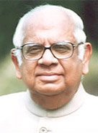

Somnath Chatterjee, Former Lok Sabha Speaker

Somnath Chatterjee is an Indian politician who was the speaker of Lok Sabha from 2004 to 2009. He was associated with the Communist Party of India

Somnath Chatterjee hon`ble speaker lok sabhaPolitical Career of Somnath Chatterjee
Somnath Chatterjee started his career as a lawyer. He was a barrister at the Calcutta High Court before joining active politics. In the year 1968 when he joined as an active member to the Communist Party of India (Marxist), he stepped into the arena of Indian Politics. He has been one of the party`s leading spokesmen. In 1971, following the death of his father, Somnath Chatterjee was given a ticket to contest an interregnum election from the same constituency of his father`s. Complying with the election, he became a Member of the Lok Sabha in 1971. And subsequently he became the first independent candidate supported by the CPI (M). Nine times he was re-elected, except once in 1984 when in the Jadavpur constituency Mamata Banerjee defeated him. He represented the Bolpur parliamentary constituency.

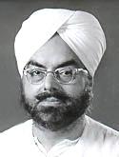

Gurdial Singh Dhillon, Indian Politician

Political Career of Gurdial Singh Dhillon
During 1950-51 Dhillon as a committed worker of the Congress Party, was the Chairman of the Punjab Congress Disciplinary Action Committee. In 1952, Dhillon was designated as the Deputy Speaker of the Punjab Legislative Assembly and remained in office till 1954. He was the President of the Amritsar District Congress Committee till 1953.
Dhillon has served as the General Secretary of the Punjab Congress Legislature Party and Chief person from 1964 to 1966. It was back in the years 1965-1966 he worked as Minister of Transport, Rural Electrification, Parliamentary Affairs and Elections and also stretched his hand for the Rehabilitation Resettlement of the 1965 war-hit areas in Punjab. Later, for two terms, he was charged as the Chairman of the Committee on Public -undertakings, for 1968-69 and 1969-70. He has also served as the member of the Panel of Chairmen.
On 8 August 1969, Dhillon was unanimously chosen as the Speaker of The Lok Sabha, following the resignation of the then Speaker Dr. Neelam Sanjiva Reddy. Dhillon was re-elected as the Speaker on 22nd March 1971, following his return to the Lok Sabha in 1971, again from the Taran Taran constituency.

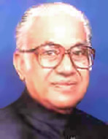

Baliram Bhagat , Indian Politician

Baliram Bhagat as Speaker of Lok Sabha
With such strong background Bhagat was designated as the Speaker of the Fifth Lok Sabha on 5 January 1976. Bhagat was nominated Speaker when the country was under Emergency. As a Speaker, Bhagat was at all times tranquil and collected even in trying situations and maintained the basic norms of parliamentary conduct. He was very particular about shielding the privileges of the members. Bhagat had a great respect for parliamentary traditions and propriety. He laid great emphasis on discipline and decorum of the parliament.

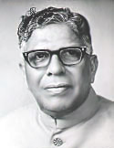

K.S. Hegde , Indian Politician

On 11 June 1909, Kawdoor Sadananda Hegde was born at village Kawdoor of Karkala Taluk in South Kanara district of the former State of Mysore. He received his primary education at the Kawdoor Elementary School and the Karkala Board High School. Then he went to the St. Alosius College, Mangalore, the Presidency College, Madras and subsequently to the Law College, Madras.

On 21 July 1977, following the resignation of Dr. Neelam Sanjiva Reddy, Hegde was elected to the office of the Speaker. The name of Hegde was proposed unanimously for the office of the Speaker. The fact should be noted in this regard that Hegde was elected as Speaker even though he was a first timer in the House spoke of his stature, ability and tolerability to all sections of the House.

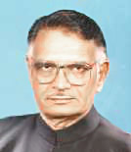

Shivraj V Patil, Indian Politician

Political Career of Shivraj V Patil
Shivraj Patil began his legislative and parliamentary career with his selection to the Maharashtra Legislative Assembly in 1972. He persevered as a member of the State Legislative Assembly from 1972 to 1977 and again from 1977 to 1979. During 1974-75, he has served as the Chairman, Committee on Public Undertakings. In 1975, Patil became Deputy Minister of Law and Judiciary, Irrigation and Protocol. He continued in office till 1976. On 5 July 1977, this voracious persona was elected Deputy Speaker of the State Assembly and held the position till 13 March 1978.
In 1980, Patil was selected to the Lok Sabha for the first time from the Latur parliamentary constituency as a candidate of the Indian National Congress (I). In 1980, Patil was made a Minister of State in the Union Council of Ministers. He had won seven successive Lok Sabha elections in 1980, 1984, 1989, 1991, 1996, 1998 and 1999.
Patil left an ineffaceable impression of his personality as the Minister of Science and Technology, Atomic Energy, Electronics, Space and Ocean Development and Biotechnology. Shivraj Patil mainly emphasized on the modernization feature of administration, application of new technologies and contriving of new processes, besides establishing latest equipment to amplify production, competence and efficiency.

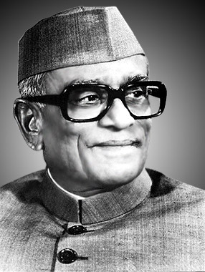

Neelam Sanjiv Reddy , Sixth President of India

Neelam Sanjiva ReddyNeelam Sanjiva Reddy was born on May 18, 1913 and died on June 1, 1996. He was the sixth President of the Republic of India, serving from 1977 to 1982.

In 1958 the degree of Honorary Doctor of Laws was bestowed upon him by the Sri Venkateswara University, Tirupathi.On June 9, 1964, He was appointed as a Member of the Union Cabinet and he got the portfolio of Steel and Mines. He was Union Minister of Transport, Civil Aviation, Shipping and Tourism from January 1966 to March 1967 in the Cabinet. He was also Elected to the Lok Sabha from Hindupur constituency in Andhra Pradesh. On March 17, 1967, he was elected as the Speaker of Lok Sabha where he won unexceptional, acclaim and appreciation. He again entered active politics in 1975 along with Shri Jayaprakash Narayan.
In March 1977, he won the Lok Sabha seat from Nandyal constituency in Andhra Pradesh. He was the only non-Congress candidate to get elected from Andhra Pradesh. On March 26, 1977 he was again unanimously elected as the Speaker of Lok Sabha.He was elected President by the electoral college in July 1977, and was the only person to be elected President of Indiawithout any opposition. He died in Bangalore, India.

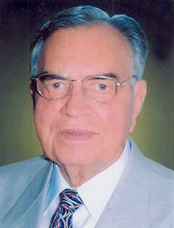

Dr. Balram Jakhar

Jakhar was elected to the Punjab assembly in 1972 and was re-elected in 1977 becoming the Leader of the Opposition. He was elected to the seventh Lok Sabha from Ferozepur in 1980 and re-elected to the eighth Lok Sabha from Sikar in 1985. He served as Speaker of Lok Sabha from 1980 to 1989. As Speaker of Lok Sabha he was an instrument for automation and computerization of Parliamentary works. He promoted Parliament library, reference, research, documentation and information services for the knowledge and use of members of Parliament. The establishment Parliament museum was his contribution. He was first Asian to be elected as Chairman of Commonwealth Parliamentarian Executive Forum. He became the Central Agriculture minister in 1991. He was Governor of Madhya Pradesh state from 30 June 2004 to 30 May 2009.

