Father's Name: | Shri Mohammad Abdul Aziz Ansari
Mother's Name: | Smt. Aasiya Begum
Date of Birth: | 1-Apr-37
Place of Birth: | Calcutta
Marital Status: | Married
Spouse's Name: | Smt. Salma Ansari
Children: | Two sons and one daughter
Educational Qualifications : | BA (Hons); MA (Political Science)

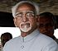

Mohamnmad Hamid Ansari

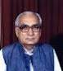

Krishan Kant
Born on: | 28-Feb-27
Father's Name: | Lala Achint Ram
Spouse's Name: | Shrimati Suman Krishan Kant
Positions Held:
Member of :
Rajya Sabha, from 1966 -1977
Lok Sabha 1977-1980

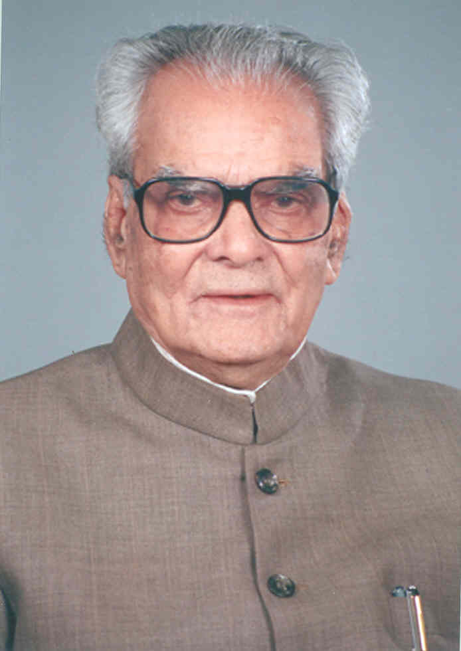

Bhairon Singh Shekhawat

Father's Name: | Late Shri Devi Singh Shekhawat
Mother's Name: | Late Smt. Bane Kanwar
Date of Birth: | 23rd October 1923
Place of Birth: | Village Khachariawas, District Sikar (Rajasthan)
Marital Status: | Married
Spouse's Name: | Smt. Suraj Kanwar
Children: | One daughter
Profession: | Farmer and Agriculturist
Permanent Address: | 72, Gaurav Nagar,  Civil Lines,  Jaipur - 302 006  (Rajasthan)  Telephone - 0141-2225487
Present Address: | 31, Aurangzeb Road,  New Delhi.

Gopal Swarup Pathak
Born on: | February 26, 1896
Father's Name: | Pandit Krishan Swarup Pathak
Spouse's Name: | Shrimati Prakashwati
Positions Held:
· Judge, Allahabad High Court, 1945-46;
· Member, Rajya Sabha, 3-4-1960 to 2-4-1966 and 3-4-1966 to 13-5-1967
· Union Minister of Law, 1966-67
· Governor, Mysore State, 13-5-1967 to 31-8-1969;
Chancellor of :
(i) Mysore University,
(ii) Bangalore University and
(iii) Karnataka University;
Vice-President of India and ex-officio Chairman, Rajya Sabha, 31-8-1969 to 30-8-1974.
Died on 31st August, 1982.
