William Shakespeare
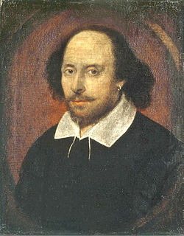
The Chandos portrait, artist and authenticity unconfirmed. National Portrait Gallery, London.
Born | Baptised 26 April 1564 (birth date unknown)  Stratford-upon-Avon, Warwickshire,England
Died | 23 April 1616 (aged 52)  Stratford-upon-Avon, Warwickshire,England
Occupation | Playwright, poet, actor
Nationality | English
Period | English Renaissance
Spouse(s) | Anne Hathaway (m. 1582–1616)
Children | - Susanna Hall  - Hamnet Shakespeare  - Judith Quiney
Relative(s) | - John Shakespeare (father)  - Mary Shakespeare (mother)
Signature

William Shakespeare (26 April 1564 (baptised) – 23 April 1616)^{[nb 1]} was an English poet and playwright, widely regarded as the greatest writer in the English language and the world's pre-eminent dramatist.^{[1]} He is often called England's national poet and the "Bard of Avon".^{[2][nb 2]} His surviving works, including some collaborations, consist of about 38 plays,^{[nb 3]} 154 sonnets, two long narrative poems, two epitaphs on a man named John Combe, one epitaph on Elias James, and several other poems. His plays have been translated into every major living language and are performed more often than those of any other playwright.^{[3]}
Shakespeare was born and brought up in Stratford-upon-Avon. At the age of 18, he married Anne Hathaway, with whom he had three children: Susanna, and twins Hamnetand Judith. Between 1585 and 1592, he began a successful career in London as an actor, writer, and part owner of a playing company called the Lord Chamberlain's Men, later known as the King's Men. He appears to have retired to Stratford around 1613 at age 49, where he died three years later. Few records of Shakespeare's private life survive, and there has been considerable speculation about such matters as his physical appearance, sexuality, religious beliefs, and whether the works attributed to him were written by others.^{[4]}
Shakespeare produced most of his known work between 1589 and 1613.^{[5][nb 4]} His early plays were mainly comedies and histories, genres he raised to the peak of sophistication and artistry by the end of the 16th century. He then wrote mainlytragedies until about 1608, including Hamlet, King Lear, Othello, and Macbeth, considered some of the finest works in the English language. In his last phase, he wrotetragicomedies, also known as romances, and collaborated with other playwrights.
Many of his plays were published in editions of varying quality and accuracy during his lifetime. In 1623, two of his former theatrical colleagues published the First Folio, a collected edition of his dramatic works that included all but two of the plays now recognised as Shakespeare's.
Shakespeare was a respected poet and playwright in his own day, but his reputation did not rise to its present heights until the 19th century. The Romantics, in particular, acclaimed Shakespeare's genius, and the Victorians worshipped Shakespeare with a reverence that George Bernard Shaw called "bardolatry".^{[6]} In the 20th century, his work was repeatedly adopted and rediscovered by new movements in scholarship and performance. His plays remain highly popular today and are constantly studied, performed, and reinterpreted in diverse cultural and political contexts throughout the world.

Works
Comedies  Main article: Shakespearean comedy  - All's Well That Ends Well ‡  - As You Like It  - The Comedy of Errors  - Love's Labour's Lost  - Measure for Measure ‡  - The Merchant of Venice  - The Merry Wives of Windsor  - A Midsummer Night's Dream  - Much Ado About Nothing  - Pericles, Prince of Tyre *†  - The Taming of the Shrew  - The Tempest *  - Twelfth Night  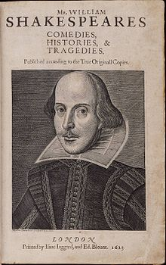  - The Two Gentlemen of Verona  - The Two Noble Kinsmen *†  - The Winter's Tale * | Histories  Main article: Shakespearean history  - King John  - Richard II  - Henry IV, Part 1  - Henry IV, Part 2  - Henry V  - Henry VI, Part 1 †  - Henry VI, Part 2  - Henry VI, Part 3  - Richard III  - Henry VIII † | Tragedies  Main article: Shakespearean tragedy  - Romeo and Juliet  - Coriolanus  - Titus Andronicus †  - Timon of Athens †  - Julius Caesar  - Macbeth †  - Hamlet  - Troilus and Cressida ‡  - King Lear  - Othello  - Antony and Cleopatra  - Cymbeline *

Poems  - Shakespeare's sonnets  - Venus and Adonis  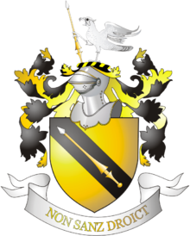  - The Rape of Lucrece  - The Passionate Pilgrim^{[nb 5]}  - The Phoenix and the Turtle  - A Lover's Complaint | Lost plays  - Love's Labour's Won  - The History of Cardenio † | Apocrypha  Main article: Shakespeare Apocrypha  - Arden of Faversham  - The Birth of Merlin  - Edward III  - Locrine  - The London Prodigal  - The Puritan  - The Second Maiden's Tragedy  - Sir John Oldcastle  - Thomas Lord Cromwell  - A Yorkshire Tragedy  - Sir Thomas More

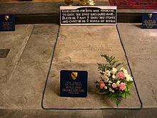
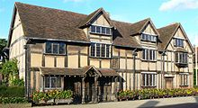

John Shakespeare's house, believed to be
Shakespeare's birthplace, in Stratford-upon-Avon.
Shakespeare's grave.

