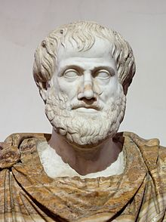
Aristotle (384 BC – 322 BC)

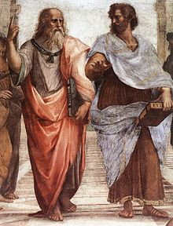
Aristotle (Ancient Greek: Ἀριστοτέλης, Aristotélēs) (384 BC – 322 BC)^{[1]} was a Greekphilosopher and polymath, a student of Plato and teacher of Alexander the Great. His writings cover many subjects, including physics, metaphysics, poetry, theater, music,logic, rhetoric, linguistics, politics, government, ethics, biology, and zoology. Together with Plato and Socrates (Plato's teacher), Aristotle is one of the most important founding figures in Western philosophy. Aristotle's writings were the first to create a comprehensive system of Western philosophy, encompassing morality, aesthetics, logic, science, politics, andmetaphysics.

Aristotle's views on the physical sciences profoundly shaped medieval scholarship, and their influence extended well into the Renaissance, although they were ultimately replaced by Newtonian physics. In the zoological sciences, some of his observations were confirmed to be accurate only in the 19th century. His works contain the earliest known formal study of logic, which was incorporated in the late 19th century into modern formal logic. In metaphysics, Aristotelianism had a profound influence on philosophical and theological thinking in the Islamic and Jewish traditions in the Middle Ages, and it continues to influence Christian theology, especially the scholastic tradition of the Catholic Church. Aristotle was well known among medieval Muslim intellectuals and revered as المعلم الأول - "The First Teacher". His ethics, though always influential, gained renewed interest with the modern advent of virtue ethics. All aspects of Aristotle's philosophy continue to be the object of active academic study today. Though Aristotle wrote many elegant treatises and dialogues (Cicero described his literary style as "a river of gold"),^{[2]} it is thought that the majority of his writings are now lost and only about one-third of the original works have survived.^{[3]}

