Deputy Speakers Of Lok Sabha
S.No | Name | Term Tenure |  | Party
 |  | From | To
1 | M.A. Ayyangar | May 30, 1952 | March 7, 1956 | Indian National Congress
2 | Sardar Hukam Singh | March 20, 1956 | March 31, 1962 | Indian National Congress
3 | S.V. Krishnamoorthy Roa | April 23, 1962 | March 3, 1967 | Indian National Congress
4 | R.K. Khadilkar | March 28, 1967 | November 1, 1969 | Indian National Congress
5 | G.G. Swell | February 9, 1970 | January 18, 1977 | All Party Hill Leaders’ Conference
6 | Godey Murahari | April 1, 1977 | August 22, 1979 | Indian National Congress
7 | G. Lakshamanan | February 1, 1980 | December 31, 1984 | Dravida Munnetra Kazhagam
8 | M. Thambi Durai | January 22, 1985 | November 27, 1989 | All India Anna Dravida Munnetra Kazhagam
9 | Shivraj Patil | March 19, 1990 | March 13, 1991 | Indian National Congress
10 | S. Mallikarjunaiah | August 13, 1991 | May 10, 1996 | Bharatiya Janata Party
11 | Suraj Bhan | July 12, 1996 | December 4, 1997 | Bharatiya Janata Party
12 | P.M. Sayeed | December 17, 1998 | February 6, 2004 | Indian National Congress
13 | Charanjit Singh Atwal | June 9, 2004 | May 18, 2009 | Shiromani Akali Dal
14 | Karia Munda | June 8, 2009 | Present | Bharatiya Janata Party

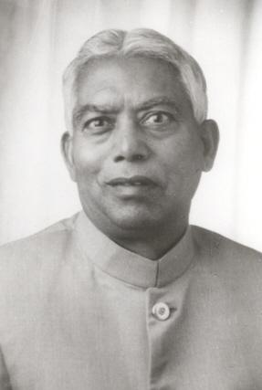

SHRI. SURAJ BHAN
Father’s Name - Late Shri Garibu Ram
Date of Birth - 1 October, 1928
Place of Birth - Village- Mehlanwali, District- Yamuna Nagar, (Haryana), India
1967 to 1970 - Elected to Fourth Lok Sabha from Ambala Constituency, Haryana.
1996 - Served as Union Minister for Agriculture .
12/7/1996 to 2/1297 - Elected Unanimously as Deputy Speaker of Lok Sabha .
Fought Continuously against casteism and work for the upliftment and welfare of the Scheduled Castes and Scheduled Tribes labourers and farmers

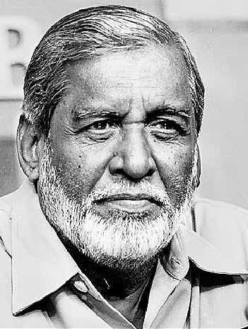

P.M. Sayeed
Mr. Sayeed, who was born on Androth island in Lakshadweep, was made a junior Minister in the Ministry of Steel, Coal and Mines in the Charan Singh Government in 1979-80. In 1993, Narasimha Rao appointed him the Minister of State for Home and in 1995 as the Minister of State for Information and Broadcasting. He became the Deputy Speaker of the Lok Sabha, for five months, in 1998. He continued to be the Deputy Speaker during the NDA rule too.

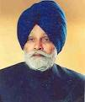

Charanjit Singh Atwal

Charanjit Singh Atwal (born 15 March 1937) is deputy speaker of the 14th Lok Sabha of India. He represents the Phillaur constituency of Punjab in 14th Lok Sabha and is a member of the Shiromani Akali Dal (SAD) political party. He is a former Speaker of the Punjab Assembly.He was born in Montgomery in Pakistan and graduated from GGN Khalsa College, Ludhiana. He obtained the LLB degree from Punjab University, Chandigarh and was Speaker of the Punjab Assembly from 1997-2002. Earlier he was a member of the Lok Sabha from 1985-1989. from 1997 to 2000 he was Chairman of the Committee on Welfare of Scheduled Castes, Scheduled Tribes and Backward Classes. He was jailed during 1975-77 emergency.

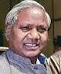

Karia Munda

He was chosen by the BJP as the Deputy Speaker candidate after the UPA offered the post to the Opposition as per convention.
Munda, a tribal leader, has been a six-time Member of Parliament from Jharkhand.
He was a Cabinet Minister in Atal Bihari Vajpayee-led NDA Government at the centre.
Born in 1936, Munda, a post graduate, was born in the Ranchi District of Bihar, now State capital of Jharkhand.
He has been elected to Lok Sabha for many terms from tribal constituency of Khunti. (AN)

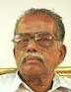

Mallikarjunaiah

He has a B.Com., B.L., M.A., P.G. Dip. in Journalism. Educated at Ramnarayan Chellaram College of Commerce, Bangalore, Sharada Vilas Law College, Mysore and Mysore University, Mysore (Karnataka) Organisational activities of R.S.S. and A.B.V.P.

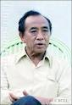

G.G. Swell
Former Deputy Speaker of Lok Sabha Prof. G. G. Swell passed away recently, bringing an end to a chequered political career that spanned nearly half a century. He was 75. He is survived by a son and a daughter. Prof Swell also served as Indian Ambassador to Norway and Myanmar in the late eighties and early nineties.
Born on August 5, 1923, at Laitkynsew village near Cherrapunjee in Meghalaya, Prof. Swell finished his schooling at the Ramakrishana Mission School at Cherrapunjee. He did his graduation from the Scotish Church College, Calcutta and Master's degree in English from the Calcutta University in 1945.
He began his political career in 1952 by contesting the Assam Assembly polls but was defeated by Rev. J.J. Nichols Roy. Soon after joining the Congress, he contested the Lok Sabha elections from Shillong constituency in 1957. In that election too, he was defeated by Hoower Hynniewt of All Part Hill Leaders Conference (APHLC).Success came his way in 1962 when he won the Shillong Lok Sabha seat on APHLC ticket. He was re-elected from the same constituency in 1967, 1971 and 1996. He spent one term in the Rajya Sabha too. In 1991, he contested in the presidential election, but lost to Congress nominee Shankar Dayal Sharma.

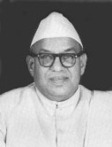

M. Ananthasayanam Ayyangar
M. Ananthasayanam Ayyangar stepped in to as the first Speaker of Lok Sabha to fill the void, which was created soon after the sudden demise of G.V. Mavalankar. M.A Ayyangar proved himself compatible to carry on the incomplete task of solidifying the gains of freedom and of sprouting a healthy parliamentary culture in the new Republic. Ayyangar left an ineffaceable indentation of his personality through a public life straddling over six decades as a lawyer, as a social activist and freedom fighter, as an outstanding parliamentarian and Speaker and as a distinguished scholar, in every area he chose to tread on in life.

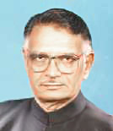

Shivraj V Patil, Indian Politician

Political Career of Shivraj V Patil
Shivraj Patil began his legislative and parliamentary career with his selection to the Maharashtra Legislative Assembly in 1972. He persevered as a member of the State Legislative Assembly from 1972 to 1977 and again from 1977 to 1979. During 1974-75, he has served as the Chairman, Committee on Public Undertakings. In 1975, Patil became Deputy Minister of Law and Judiciary, Irrigation and Protocol. He continued in office till 1976. On 5 July 1977, this voracious persona was elected Deputy Speaker of the State Assembly and held the position till 13 March 1978.
In 1980, Patil was selected to the Lok Sabha for the first time from the Latur parliamentary constituency as a candidate of the Indian National Congress (I). In 1980, Patil was made a Minister of State in the Union Council of Ministers. He had won seven successive Lok Sabha elections in 1980, 1984, 1989, 1991, 1996, 1998 and 1999.
Patil left an ineffaceable impression of his personality as the Minister of Science and Technology, Atomic Energy, Electronics, Space and Ocean Development and Biotechnology. Shivraj Patil mainly emphasized on the modernization feature of administration, application of new technologies and contriving of new processes, besides establishing latest equipment to amplify production, competence and efficiency.

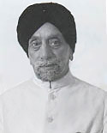

Sardar Hukam Singh, Indian Dy. Speaker

The charming personality, Hukam Singh was born on 30 August 1895 at Montgomery, now a part of Pakistan. In 1917, Hukam Singh did his graduation from the Khalsa College, Amritsar, after finishing his matriculation from the Government High School, Montgomery. Thereafter, at the Law College, Lahore he studied Law and started practicing in his hometown Montgomery after passing out in 1921.

Hukam Singh was harked back for the third time to the Lok Sabha, through the General Elections that was held in 1962. This time he contested on a Congress ticket from the Patiala parliamentary constituency. Hukam Singh without dissent was elected as the Speaker of the Third Lok Sabha having been tested and fully confirmed his credentials. It was believed that the office of the Speaker was safe in the hands of Hukum Singh, who ardently endorse the self-esteem of Parliament and the civil rights and constitutional rights of its members.

