Kurnool District – Historical Places
Kurnool District is a district in the state of Andhra Pradesh, India, located in the west-central part of the state on the southern banks of the Tungabhadra and Handri rivers. The town of Kurnool is currently the headquarters of the district. It had a population of 3,529,494 of which 23.16% were urban as of 2001.^{[1]}
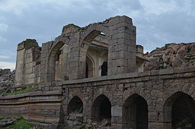
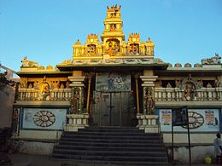

Hall of The Nawab at Adoni fort in Kurnool District
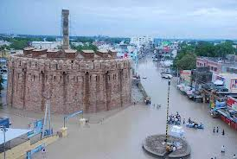
Veerabrahmendra Swamy Temple in Banaganapalle
Kondareddy Buruju
Telugu, Urdu^{[2]} and Kannada are the most widely spoken languages.

History

Palaeolothic era
The Ketavaram^{[3]} rock painting's are dated back to the Paleolithic era (located at a distance of 18 Kilometer from Kurnool). Also the Jurreru Valley, Katavani Kunta^{[4]} andYaganti in Kurnool District have some important rock art's and painting's in their vicinity, may be dated back to 35,000 to 40,000 years ago.

Buddhism and Jainism
Belum Caves are geologically and historically important caves in the district. There are indications that Jain's and Buddhist monks were occupying these caves centuries ago. Many Buddhists relics were found inside the caves. These relics are now housed in Museum at Ananthapur.
Archaeological survey of India (ASI) also found remnants of vessels, etc. of pre-Buddhist era and has dated the remnants of vessels found in the caves to 4500 BC.^{[5]}

Medieval era
In 12th century AD, the Odders, who carted stones for the construction of the temple at Alampur, Mahaboobnagar District, on the left bank of the River Thungabhadra, used the site where the town now stands as a stopping place before crossing the Tungabhadra. They greased their cart wheels with oil supplied by local oil merchants and called the place 'Kandanavolu' which in course of time came to be known as Kurnool.
Of historical interest are the ruins of a royal fort dating back to the medieval kingdom of Vijayanagar, which flourished from the 14th to the 16th century. Several Hindu Temple's as Ahobilam, Mahanandi, Yaganti, Srisailam, Kolimigundla, Omkaram were developed during the era of Vijayanagar Dynasty.
Several Persian and Arabic inscriptions which throw light on various aspects of historical interests are found here. In Kurnool there are 52 dargahs (shrines) located around the Thungabhadra and Hundari rivers. A very famous and lengthy K.C. Canal starts in Kurnool and ends in Cuddapah. It is around 300 kilometers long. In Kurnool city there are a number of ancient temples, churches and mosques. Kurnool city, known as the gateway to the Rayalaseema, on N.H.7 (Kanyakumari to Varanasi) on the banks of the Rivers Thungabhadra and the Hundri was the capital of the first linguistic state in free India, Andhra State from 1 Oct. 1953 to 31 Oct. 1956. As such it has some historical buildings.
Kurnool has freedom fighters like Vuyyalawada Narsimha Reddy, Gadicharla Harisarvothama Rao. Zilla Grandhalaya Samstha (ZGS ) and the District Central Libray (DCL), Kurnool, building near the old Bus stand is named 'GADICHARLA HARISARVOTHAMA RAO SMARAKA BHAVANAMU". It is the second district, apart from Nellore (Bejawada Gopal Reddy 'Andhra state' & Nedurumalli Janardhan Reddy), which has contributed two Chief Ministers to Andhra Pradesh:
- Damodaram Sanjeevaiah (1st dalit Chief Minister of India and A.P),
- Kotla Vijaya Bhaskar Reddy
- 10th Indian Prime Minister P.V. Narasimha rao was elected as member of parliament from Nandyal constituency with over 6 lakh (600,000) majority, a world record.
Neelam Sanjeeva Reddy (Ananthapur District) was elected from the Dhone assembly constituency in 1962 general elections and became the Chief Minister of AP. Again in 1977 general elections to the Lok Sabha, he won from the Nandyal Parliamentary constituency and became the speaker of the Lok Sabha. However he resigned and became the 6th President of the Republic of India. In 1970, part of Kurnool district was split off to become part of Prakasam district.^{[6]}
Kurnool District is currently a part of the Red Corridor.^{[7]}

Geography
Kurnool district occupies an area of approximately 17,658 square kilometres (6,818 sq mi),^{[8]} comparatively equivalent to New Caledonia.^{[9]}
Kurnool is surrounded by Districts of both Andhra Pradesh and Karnataka,
North- Mahabub Nagar
South- Anantapur, KADAPA (Cuddapah)
East- Praksam (Ongole)
West- Bellary (A district in Karnataka State)
The Nallamalas and Erramalas mountain ranges in the district run parallel from the North to South. The ranges divide the district into two tracts crossed by the Krishna and Pennar rivers. The North Pagidyala mandal is about 1000 above sea level. From this height the ground slopes to the South along the river Kundu until it traverses into the Pennar valley. Major part of its tract is black soil. Between the Erramalas and Nallamalas lies the Eastern part of the district.

Gallery

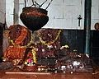
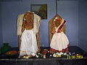

Gangammagudi in Chapirevula
Naganandi Lingam - Nandyal

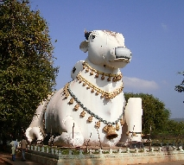
Mahanandi is a village located east of the Nallamala Hills near Nandyal, Kurnool District, Andhra Pradesh, India. It is a pictures village surrounded by thick forests. Within 15 km of Mahanandi, there are nine Nandi shrines known as Nava Nandis. Mahanandi is one of the Nava Nandis. The Mahanandiswara Swamy Temple, an important shrine, is located here. This ancient temple dates back over 1,500 years. The inscriptions of 10th century tablets speak of the temple being repaired and rebuilt several times.
The Largest Nandi in the World
These nine temples are Mahanandi, Shivanandi, Vinayakanandi, Somanandi, Prathamanandi, Garudanandi, Suryanandi, Krishnanandi (also called Vishnunandi) and Naganandi.
A festival is held here annually during February and March to celebrate Maha Shivaratri, the Great Night of Shiva.
Mahanandi is about 14 km from Nandyal Bus Stop. The nearest airport is at Hyderabad, which is about 215 km from Kurnool, and the nearest railway station is at Nandyal.
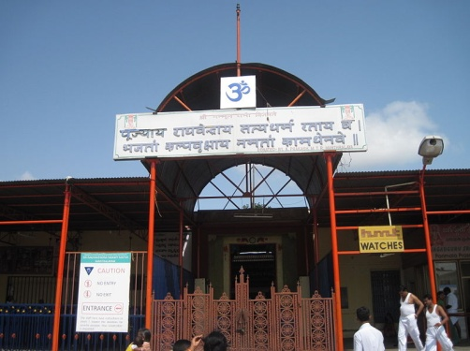
Mantralayam is a town in Kurnool district inAndhra Pradesh, India. It lies on the banks of the Tungabhadra river on the border with neighbouring Karnataka state. It is also called as Manchale. This town is noted for the holy presence of the Vrindavana of Guru Raghavendra Swami, a Madhwa saint and follower of Sri Madhwacharya. It is believed that Guru Raghavendra Swami is in the Vrindavana from the past 339 years and is believed to be in the Vrindavana for another 361 years. While entering the Vrindavana, Guru Raghavendra Swami stated that he would be there (in the Vrindavana) for 700 years.
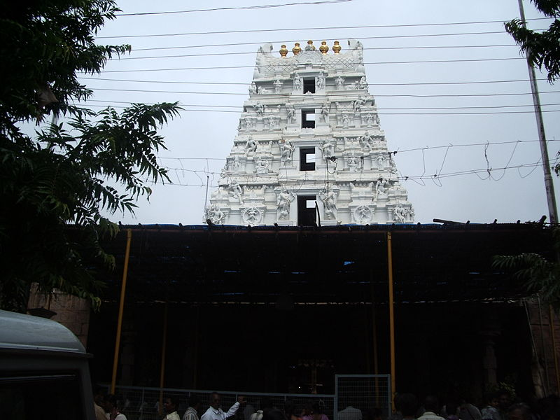
Srisailam (Telugu: శ్రీశైలం) is a holy town and mandal, situated in Nallamala Hills ofKurnool district, Andhra Pradesh, India. It is on the banks of River Krishna, about 212 km south of Hyderabad.
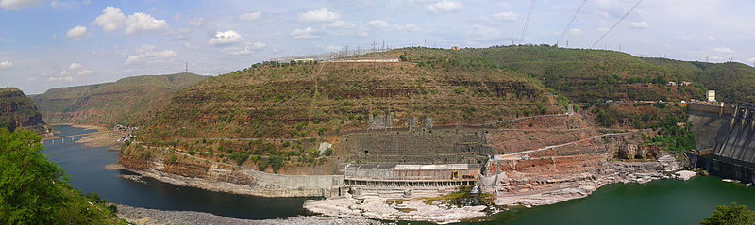
Bhramaramba Mallikarjunaswamy Temple dedicated to Lord Mallikarjuna Swamy (a form of Shiva) and Devi Bhramaramba (a form of Parvathi) is located here and it is one of the 12 Jyotirlinga temples dedicated to Lord Shiva. Srisailam Dam, located about 212 km from Hyderabad and 132 km from Nandyal, is a multipurpose dam built across River Krishna and caters to the irrigation and power needs of the state.
Srisailam Project

Sri Yaganti Uma Maheswara Temple ( యాగంటి) is a temple toLord Shiva in Kurnool District in the Indian state of Andhra Pradesh.
This temple was constructed by King Harihara Bukka Rayalu of the Sangama Dynastyof the Vijayanagara Empire in the 15th century. It was built according to Vaishnavaitetraditions.
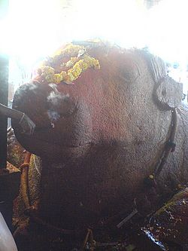
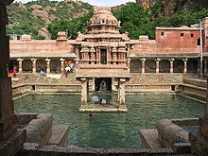

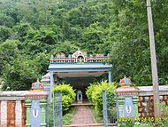
Ahobhilam (Telugu: అహోబిలం, Sanskrit: अहोबिलं) also known as Ahobalam is located in the Allagadda mandal of Kurnool district in Andhra Pradesh, India. It is located at a distance of 40 km from Nandyal and about 150 km from Kurnool, the districtheadquarters. There are two temple houses, lower Ahobilam and upper Ahobilam.
According to the legend, this is where Lord Narasimha blessed Prahlada and killed thedemon Hiranyakashipu.

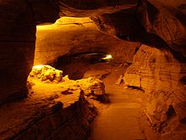
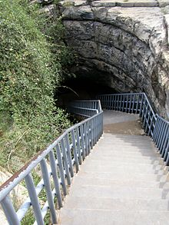
Belum Caves is the second largest cave in Indian subcontinent and the longest caves in plains of Indian Subcontinent, known for its stalactite and stalagmite formations. Belum Caves have long passages, spacious chambers, fresh water galleries and siphons. The caves reach its deepest point (120 feet from entrance level) at the point known asPataalaganga. Belum Caves derives its name from "Bilum" Sanskrit word for caves.^{[1]} InTelugu language, it is called Belum Guhalu. Belum Caves has a length of 3229 metres, making it the second largest natural caves in Indian Subcontinent.
Originally discovered in 1884 by a British surveyor Robert Bruce Foote, later in 1982-84, a team of German speleologists headed by H Daniel Gebauer conducted a detailed exploration of the caves. Thereafter in 1988, the state government declared them protected, and Andhra Pradesh Tourism Development Corporation (APTDC) developed the caves as a tourist attraction in February 2002. Today, 3.5 km of the cave has been successfully explored, though only 1.5 km is open to tourists.^{[1]}

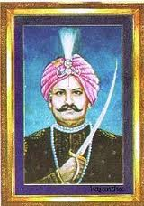
Uyyalawada Narasimha Reddy is credited to be one of the first freedom fighters in India. He led one of the first revolts in India againstBritish occupation, 10 years earlier than the Sepoy Rebellion of 1857.
Narasimha Reddy, as a polygar of Koilkuntla was in command of 66 villages in Kadapa, Anantapur, Bellary and Kurnool districts and controlled an army of 2000. After Rayalaseema was ceded to the British by the Nizam, Narasimha Reddy refused to share the revenue of the region with the British. He was in favor of an armed uprising. On 10 June 1846 he attacked the treasury at Koilkuntla and marched towards Cumbum (Prakasam District). On the way, he created uproar at Rudravaram by killing the forest ranger. The district collector, Thomas Monroe, took a serious view of the rebellion and ordered his capture. Early attempts to capture him under Captain Knot and Watson were unsuccessful.The British government announced Rs 5000/ for the information and Rs 10000/ for his head which was a huge amount in those days.

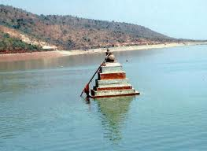
The Sangameswara temple (Telugu: సంగమేశ్వ దేవస్థానము) is an ancient Hindu temple in the Kurnool district, Andhra Pradesh, India. It is located near Muchumarri at the confluence of the Krishna and Bhavanasi rivers, in the foreshore of the Srisailam reservoir,^{[3]} where it is submerged for part of the time, surfacing when the water level recedes to a sufficient degree.^{[4]} It was first submerged after the Srisailam Dam was constructed in 1981, and first surfaced in 2003.^{[2]}
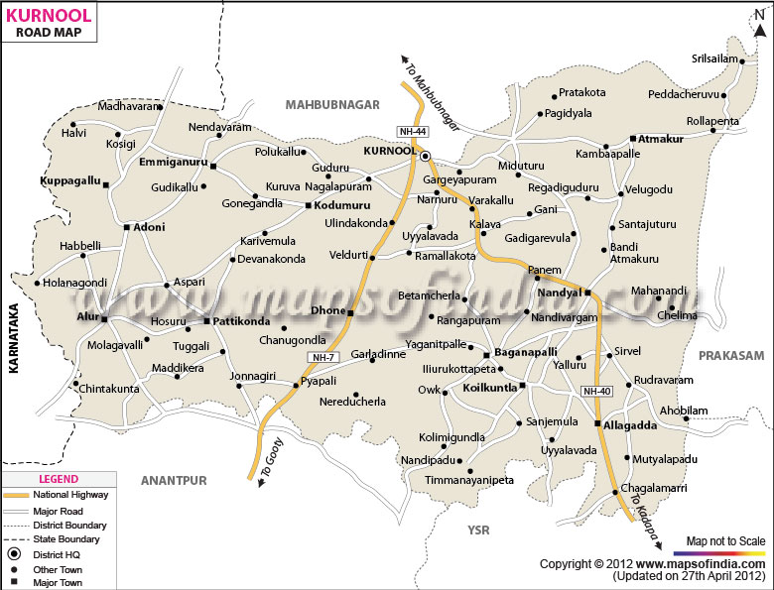
The temple's wooden Lingam, Sangameswaram, is believed to have been installed by Dharmaraja, the eldest of thePandavas, after their visit to Srisailam Mallikarjuna temple. The temple is considered a place of religious sanctity due to being built at the confluence of seven rivers (Bhavanasi, Krishna River and its five rivers that merge into it namely, Veni, Tunga, Bhadra, Bheemarathi and Malapaharini).

